

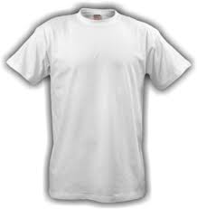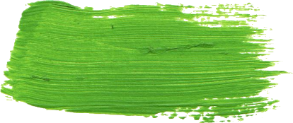

**Summer School, 2021**

**<<<<<<<<<< TEXTILE AND DYE >>>>>>>>>>**

**Application Form**

|  |  |
| --- | --- |
| Name of the applicant (teacher): |  |
| Contact information (e-mail, Tel.): |  |
| School of the applicant: |  |
| School address: |  |
| Number of participants  (students + teachers): |  |

List of student-participants:

|  |  |  |  |  |  |
| --- | --- | --- | --- | --- | --- |
| No. | Name | Surname | No. | Name | Surname |
| 1 |  |  | 11 |  |  |
| 2 |  |  | 12 |  |  |
| 3 |  |  | 13 |  |  |
| 4 |  |  | 14 |  |  |
| 5 |  |  | 15 |  |  |
| 6 |  |  |  | | |
| 7 |  |  |
| 8 |  |  |
| 9 |  |  |
| 10 |  |  |

List of other attendees (teachers, parents, etc.)

|  |  |  |
| --- | --- | --- |
| No. | Name | Surname |
|  |  |  |
|  |  |  |
|  |  |  |

Supporting information:

The exact date and time, as well as the location of the event will be announced in May 2021. Your students will spend one day in our lab. The event includes a 1-hour lecture, an interactive game workshop and a set of laboratory experiments. We provide all the equipment, including lab coats and goggles.

Send this form to [narmin.suvarli@kit.edu](mailto:narmin.suvarli@kit.edu) by 1st of June 2021.

Additional notes:

The event will take place in English. In case the Covid-regulations will not allow the event to take place on site, it will be moved online.

_________________ __________________

Date, place Signature